1. public class ExceptionEx1 {

public static void main(String args[]) {

int[] nums = {3, 2, 6, 1};

badUse(nums);

}

public static void badUse(int[] vals) {

int total = 0;

for (int i = 0; i < vals.length; i++) {

try {

int index = vals[i];

total += vals[index];

} catch (ArrayIndexOutOfBoundsException e) {

System.out.println("Index " + vals[i] + " is out of bounds. Skipping this index.");

}

}

System.out.println("Total: " + total);

}

}

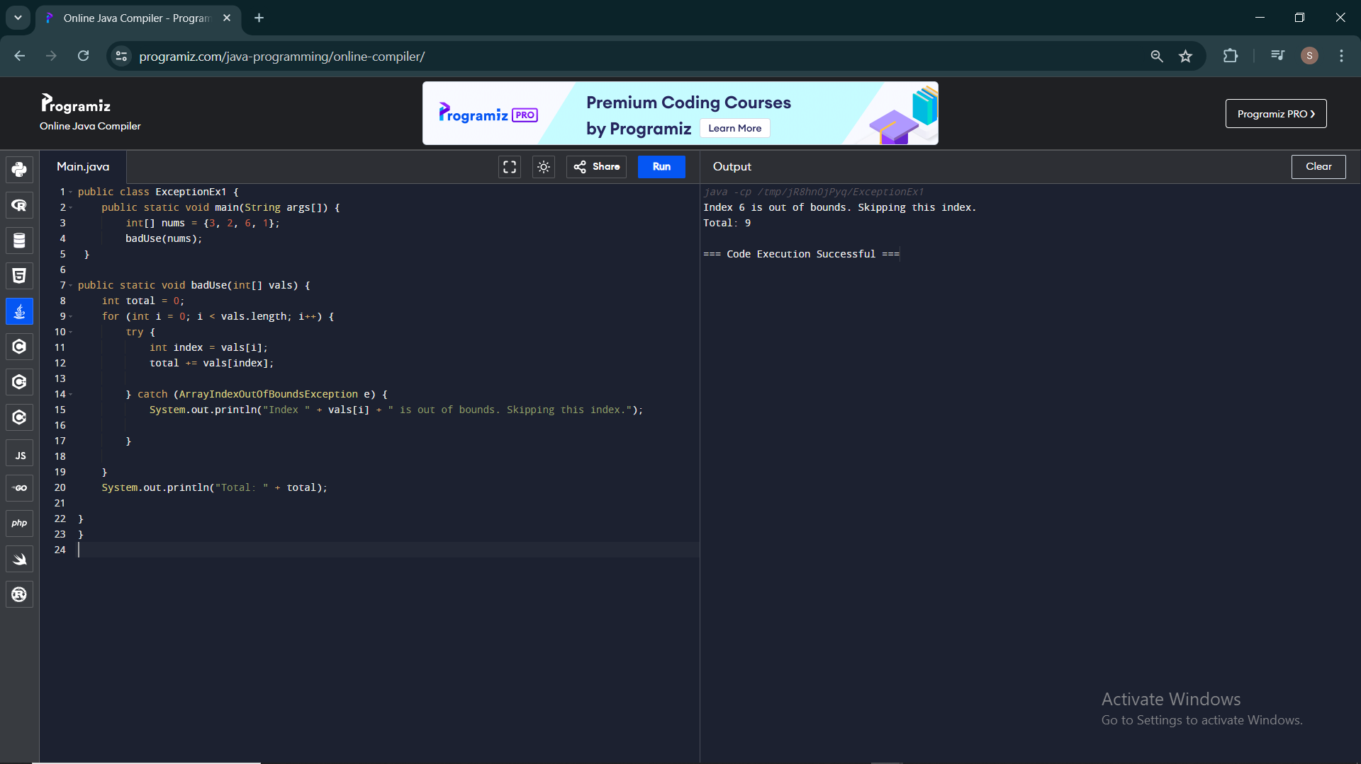

2.public class Calculator {

public int add(int x, int y) {

return x + y;

}

public double divide(int x, int y) {

try {

return x / y;

} catch (ArithmeticException e) {

System.out.println("Error: Division by zero is not allowed.");

return Double.NaN;

}

}

public static void main(String[] args) {

Calculator calculator = new Calculator();

int a = 10;

int b = 0;

System.out.println("Addition: " + calculator.add(a, b));

System.out.println("Division: " + calculator.divide(a, b));

}

}

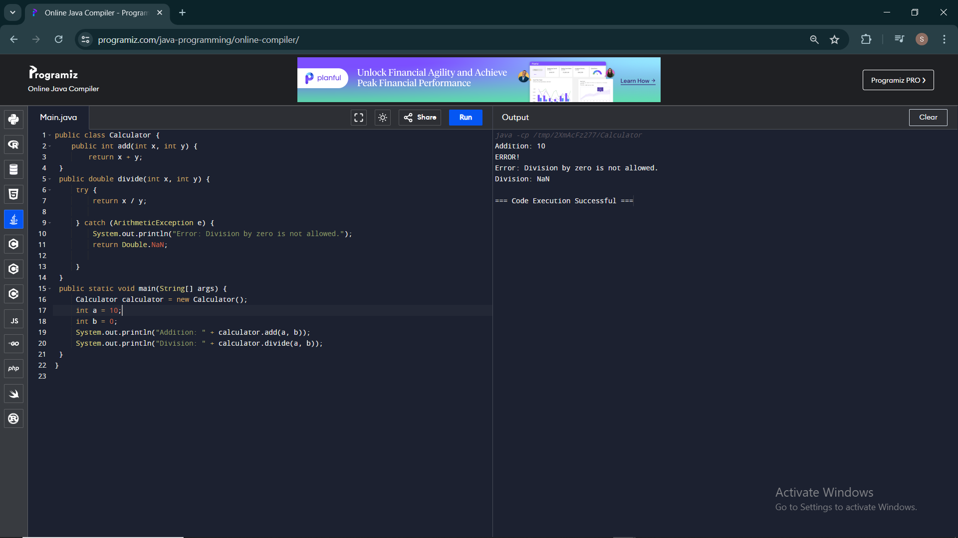

3.class Calculator {

public int add(int a, int b) {

return a + b;

}

public double divide(int a, int b) {

if (b == 0) {

throw new ArithmeticException("Division by zero is not allowed.");

}

return (double) a / b;

}

}

public class ShoppingCart {

public static void main(String[] args) {

Calculator calc = new Calculator();

int addResult = calc.add(43, 79);

System.out.println("Add Result: " + addResult);

try {

double divResult = calc.divide(15, 0);

System.out.println("Division Result: " + divResult);

} catch (ArithmeticException e) {

System.out.println("Error: " + e.getMessage());

}

}

}

